1. What is sub domain enumeration ?

Subdomain enumeration is the process of identifying all valid subdomains associated with a specific domain name. It's a crucial step in reconnaissance for security assessments, bug bounty hunting, and even organizational management, as it helps expand the attack surface and understand a target's infrastructure.

1. Use Passive Tools -

* Godaddy.com | using **sublist3r tool**. Approx 3500 domains

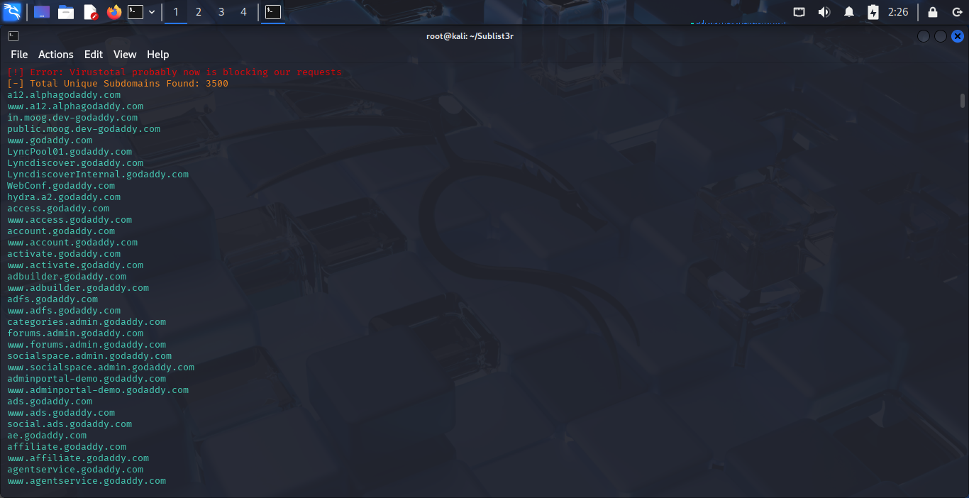

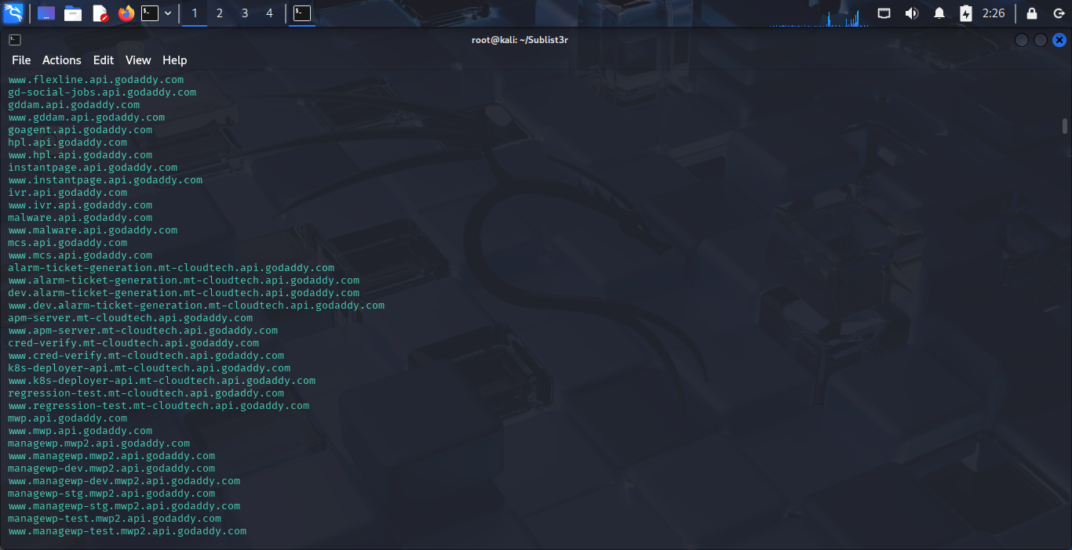

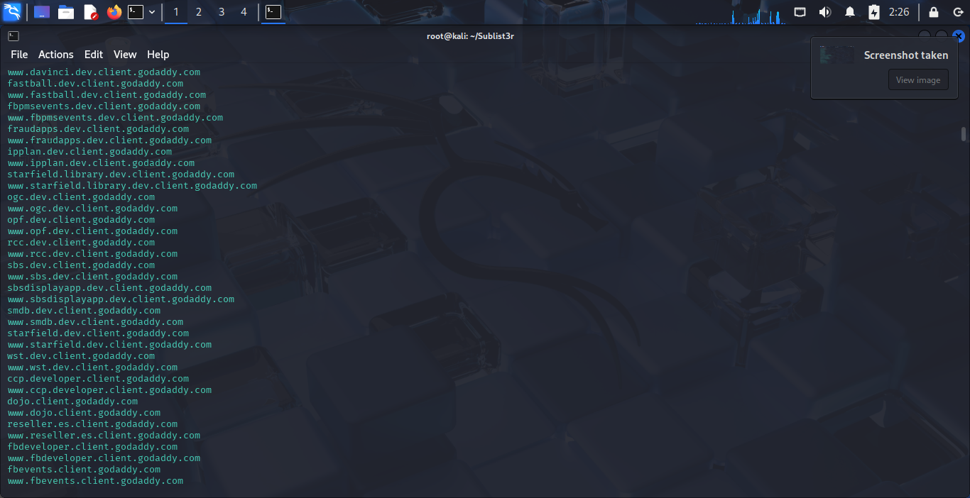

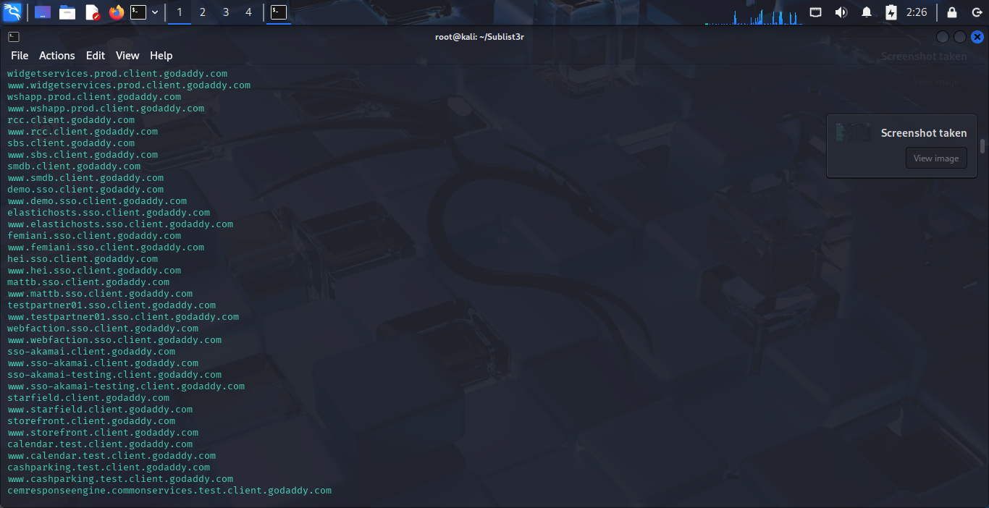

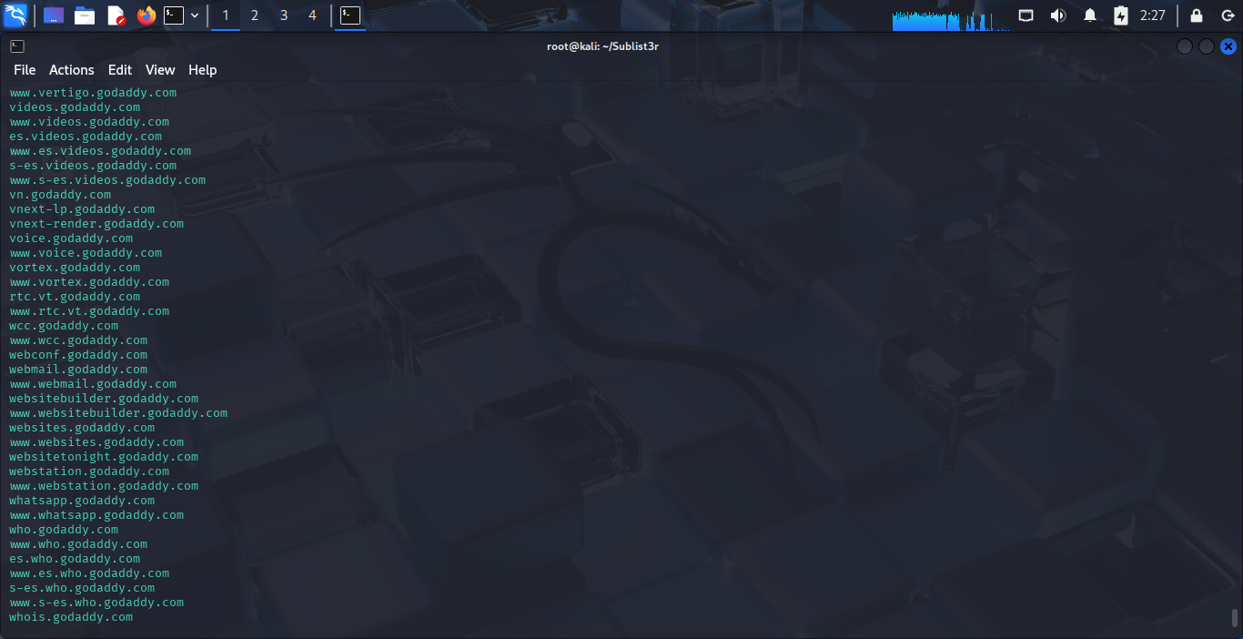

* Godaddy.com | using **amass tool**. Approx 600 domains

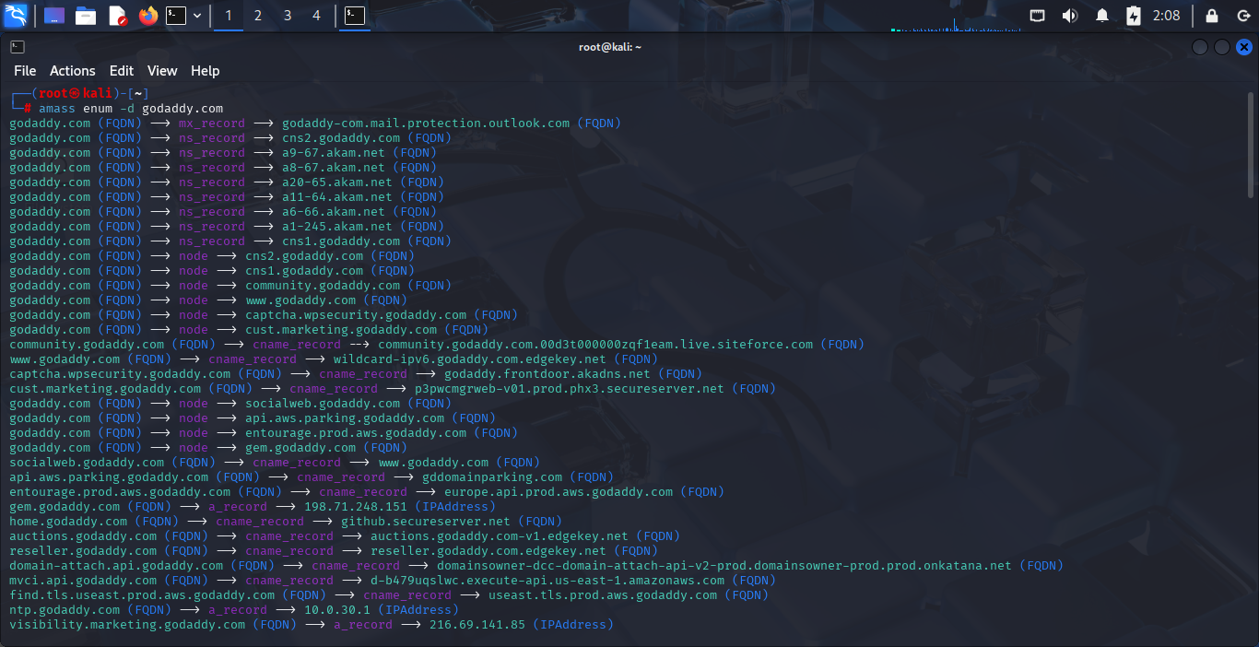

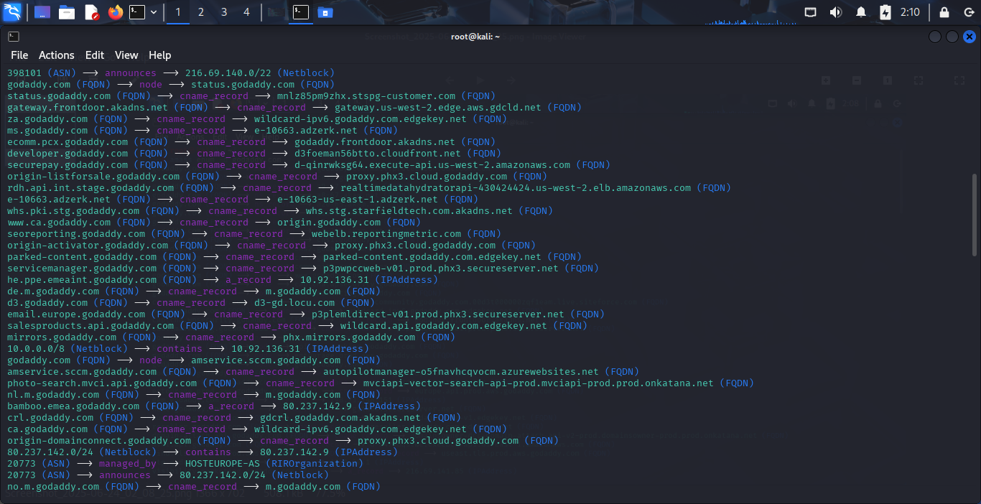

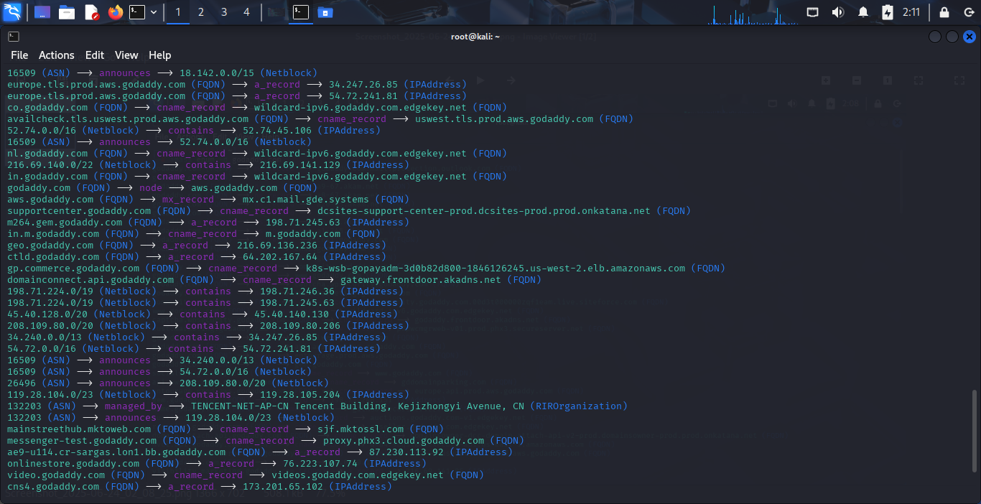

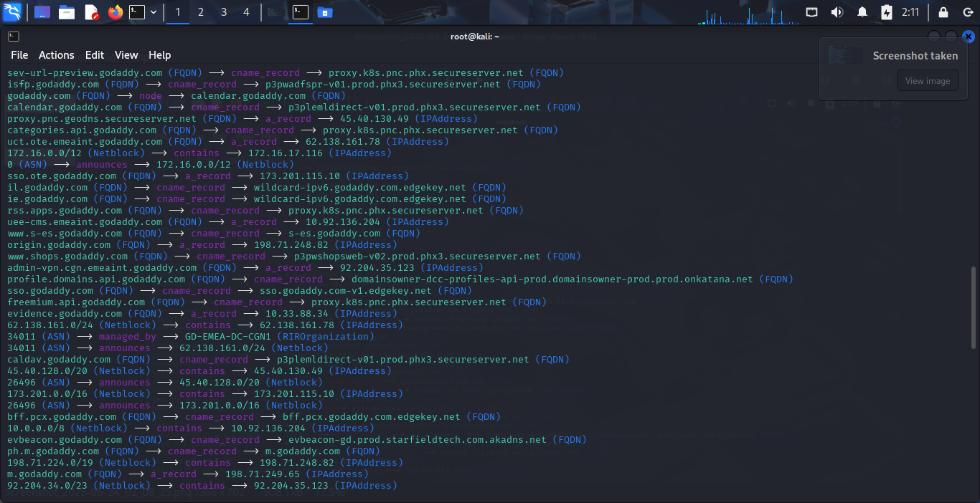

1. Compare the results :

We are using virustotal.com (website) to identify subdomains in Godaddy.com

We got around 678 domains as shown in screenshot.

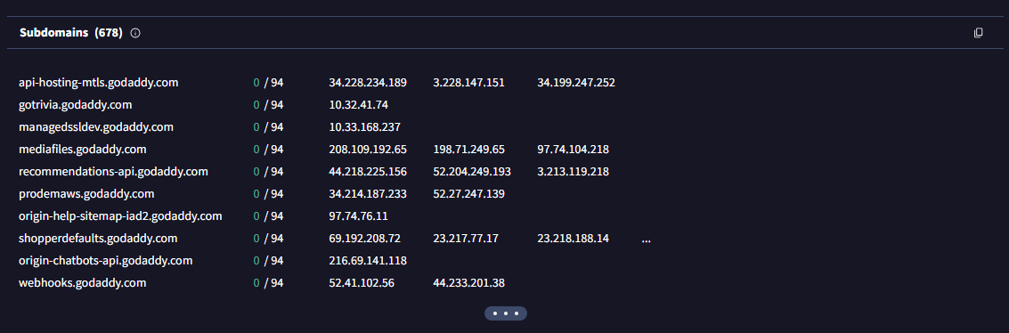

**Summary :**

By using Amass tool we got 600 subdomians.

By using Sublist3r tool we got 3500 subdomians.

By using Virustotal web tool we got around 678 subdomains.

.